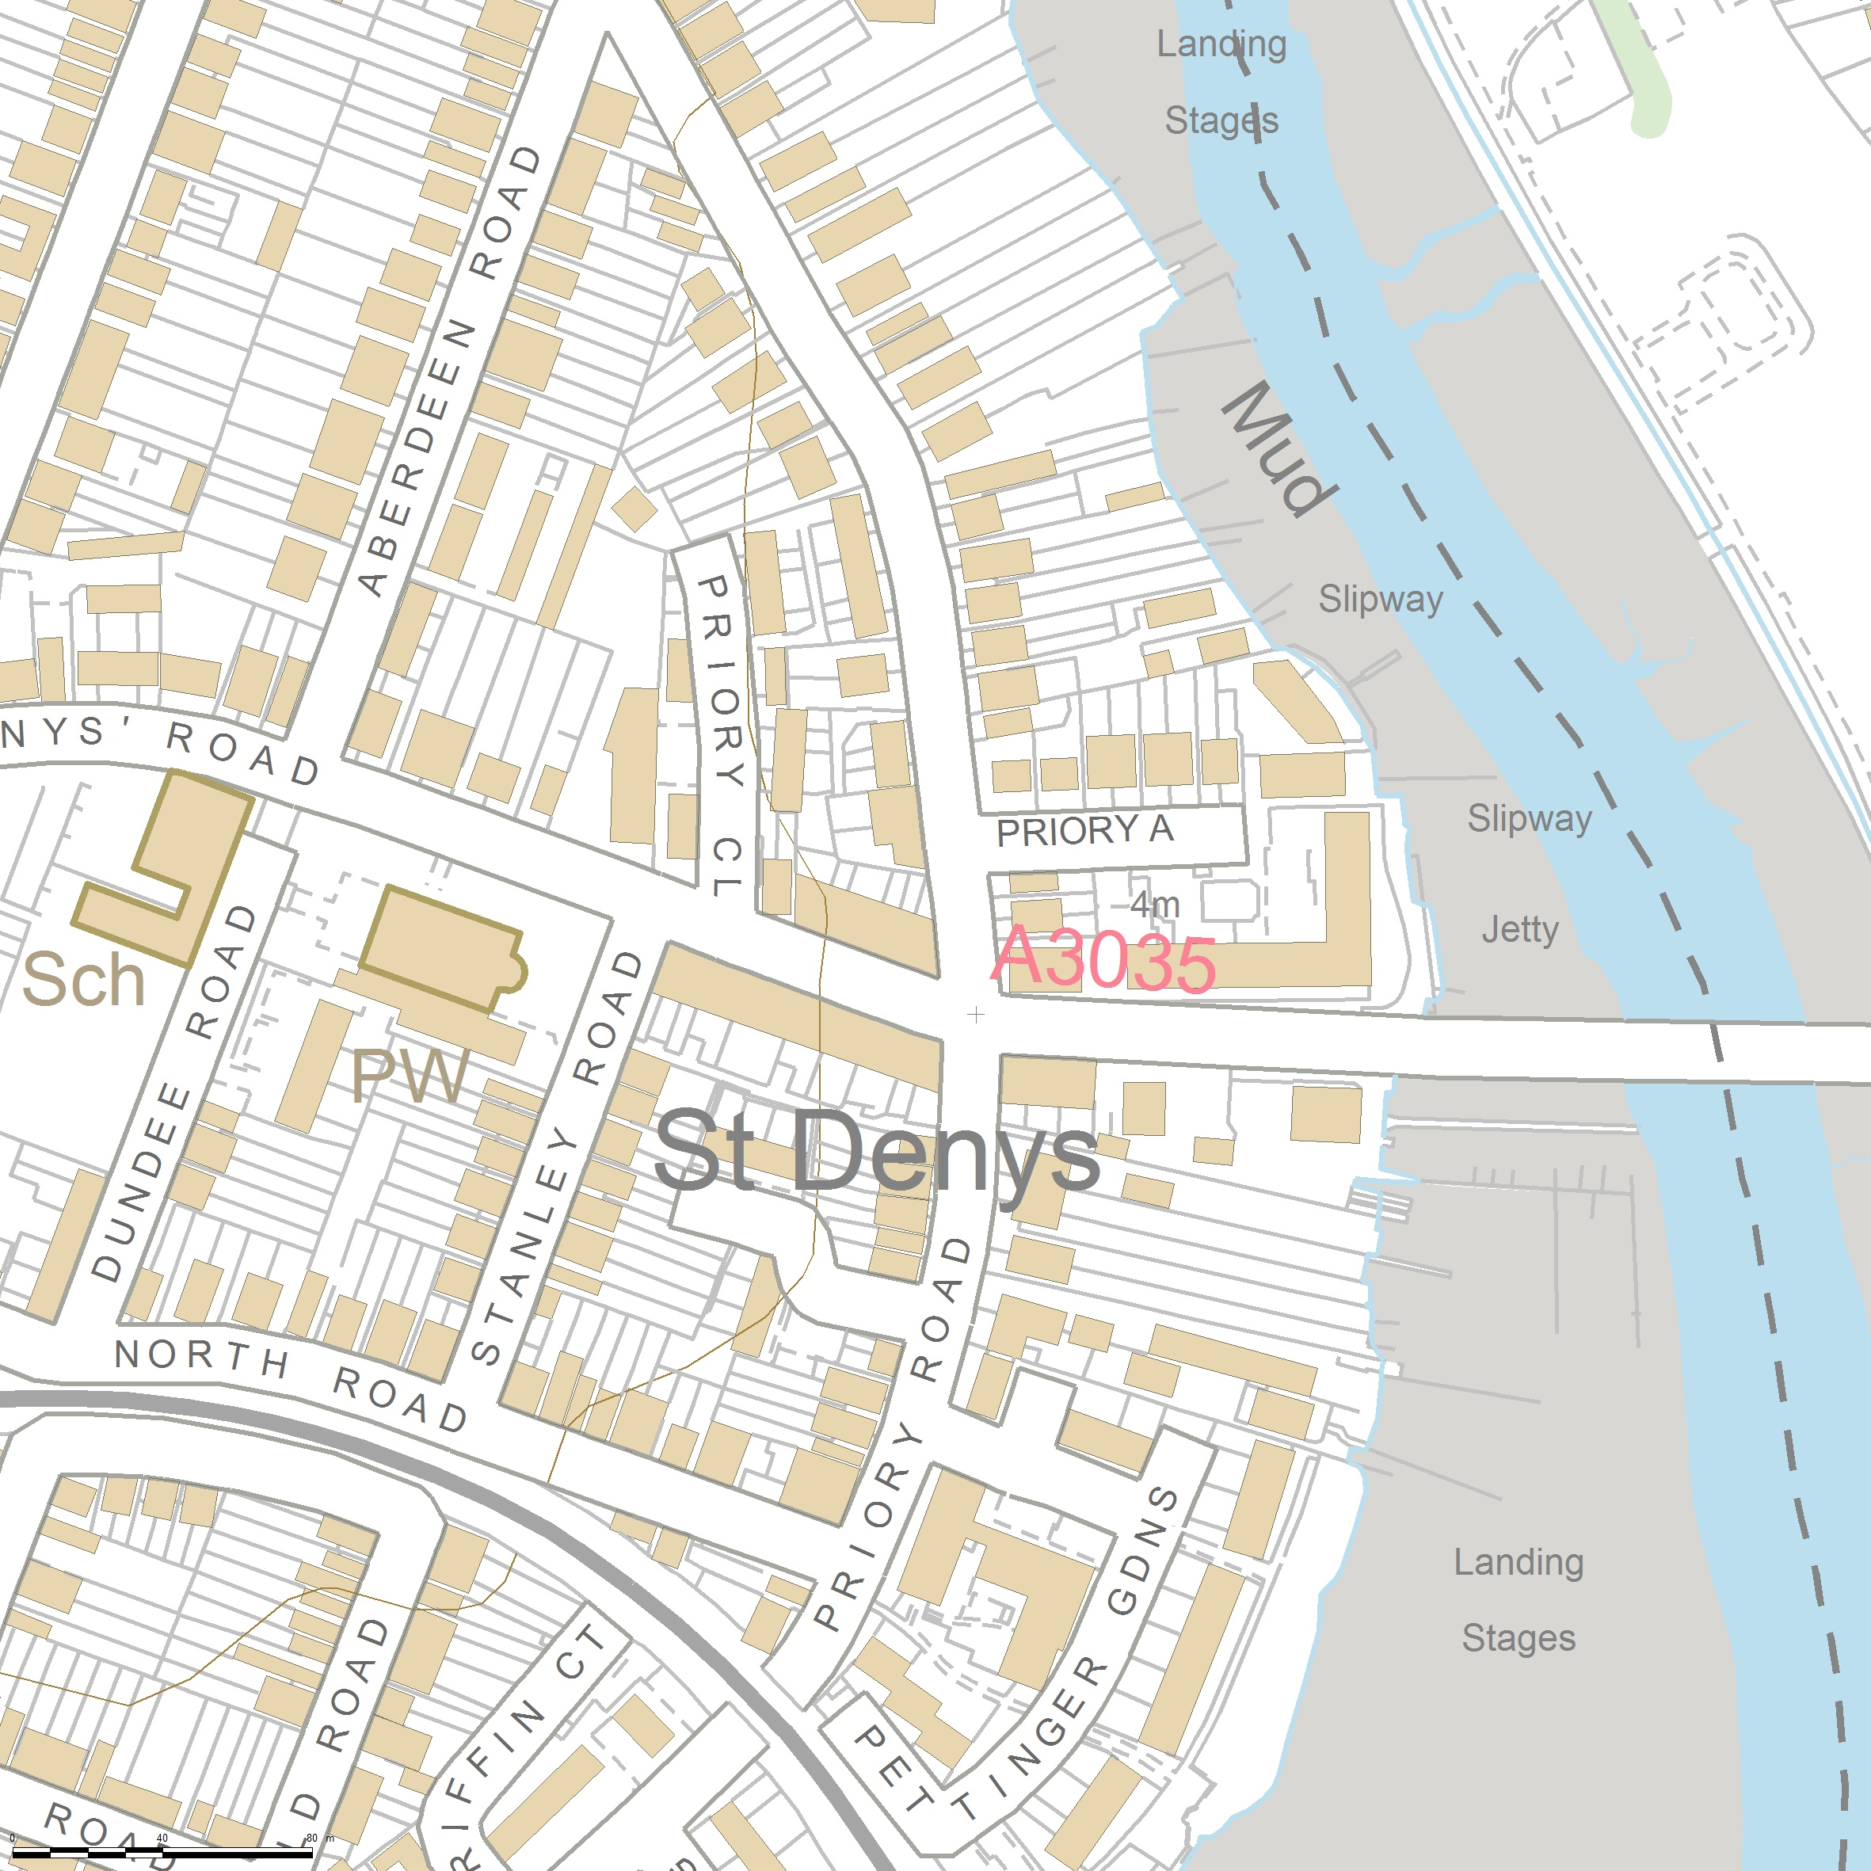
Vector Map Local 500m x 500m
SCALE 1:2500

CENTRE COORDINATES: 443581, 114101



Supplied by Streetwise Maps Ltd
www.streetwise.net
Licence No: 100047474

